小学英语六年级上册(PEP)期末测试卷

学校 班级 姓名


(Listening Part) 听力部分
Ⅰ、Listen and choose(听录音，选择) 10％
A.
B.
C.
A.
B.
C.
A.
C.
1.（ ）

2.（ ）

A.
B.
C.
3. （ ）

C.
4. （ ）
B.

A.
5.（ ）
B.

Ⅱ、Listen and tick or cross（根据听到的对话，判断正误，对的画 ，错的画 ） 10%
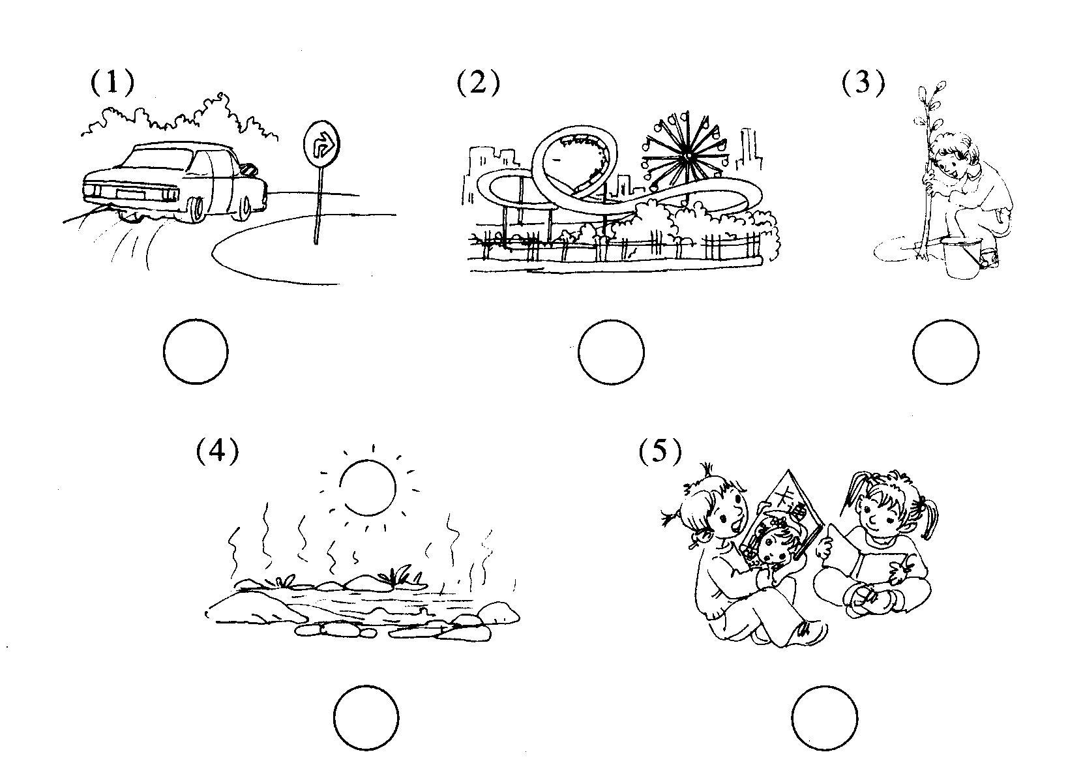
Ⅲ、Listen and choose（听对话，选择正确的答案）10%
( )1.How does Amy go to school?
A. on foot B. by bike C by bus
( )2.Where is the cinema?
A. Next to the hospital. B. Near the post office. C. In front of the post office.
( )3.What are you going to do?
A. I’m going to the bookstore. B. I’m going to visit my grandparents.
C. I’m going to buy a comic book.
( )4.What is Liu Yun’s hobby?
A. Playing the violin. B. making kites C. Collecting stamps.
( )5. What dose your mother do?
A. An engineer. B. A policeman. C. An accountant.
Ⅳ.Listen and judge.(听录音，判断，对的打√，错的打×。) 5%
( ) 1. Chen Lei is a salesperson.
( ) 2. He goes to work by bus.
( ) 3. He likes drawing pictures.
( ) 4. He works in an air-conditioner company.
( ) 5. He is going to the bookstore this weekend.

(Reading and writing) 读写部分
Ⅰ、Read and match.(读单词，连线) 10%
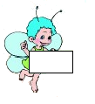
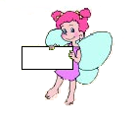
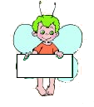
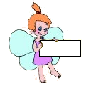
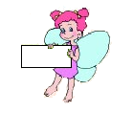

stamp
teacher
south
artist
vapour

Ⅱ、Read and find（找出不同类的单词）10%
( ) 1. A. actor B. father C. teacher D. cleaner
( ) 2 A. cloud B. rain C. sun D. seed
( ) 3 A. classroom B. bookstore C. superman D. shoe store
( ) 4 A. bus B. foot C. plane D. subway
( ) 5 A. east B. west C. straight D. south
Ⅲ、listen and choose.(选择正确答案，将序号填在括号内)10%
( ) 1. ________ at a green light.
A. Stop B. Wait C. Go
( ) 2.When are you going?
A. I’m going on foot. B. I’m going at 7:30. C. I’m going to school.
( ) 3.Does she watch TV at night?
A. Yes, she do. B. Yes, she does. C. No, he doesn’t.
( ) 4. Mary’s uncle is _____ doctor, her aunt is ______ artist.
A. a , an, B. a, a C an, a
( )5.Where does the rain come from?
A. It comes from the clouds. B. It comes from the vapour.
C. It comes from the water in the river.
Ⅳ、Make sentences according to the words below (连词成句。) 10 %
1、
lives
in
Shanghai
He
.

a
red
Stop
light
at
.
2、

3、
How
does
she
to
go.
work
.

Ⅴ、Read and number （读句子，标序号）10%
( ) Add water often.
( ) Put the pot under the sun.
( ) Plant the seeds in the soil.
( ) Wait for a flower to grow.
( ) Wait for a sprout.
VI、Read and write(阅读文章，并回答问题)15%

Look at my pen pal’s album. This is Lily, my pen pal. She lives in New Zealand(新西兰).It ’s next to Australia(澳大利亚).She is a quiet girl. She likes playing the violin and drawing comic pictures. She wants to be an artist in the future. She goes to school on foot. She has a brother. His name is Jill. He is only five. He likes riding his small bike in the garden and playing with his toy cars. Her father is a baseball player. Her mother is an accountant. She works in a bank. They both go to work by car. They are very happy.
1、Where is New Zealand? ( )
A. It’s next to America. B. It’s next to Australia. C. It’s next to China.
2、What’s Lily’s hobby? ( )
A. She likes playing the violin and drawing comic pictures.
B. She likes riding his small bike in the garden and playing with his toy cars.
C. She likes drawing comic pictures and riding a bike.
3、What does her father do? ( )
A. He’s a baseball player B. He’s a football player C. He’s a policeman
4、How does her father go to work? ( )
A. On foot. B. By bus. C. By car.
5、Does Jill like riding his small bike in the garden? ( )
A．Yes, he does. B. No, he doesn’t C. Yes, she does.
6、What does Lily want to be in the future? ( )
A. An actress. B. An artist. C. A singer
7 、What do you want to be in the future? Why?
I want to be .Because .

